**System.out.println() in Java**

In java language **print()** and **println()** are the predefined non-static method of printStream class used to display value or message either in the same line or line by line respectively. PrintStream class is having fixed object reference in the **System** class (existing as a static properties) so that either print() or println() method can be called with following syntax..

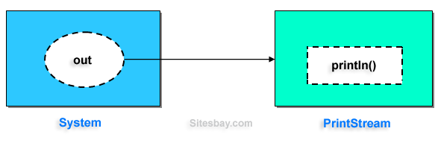

**Syntax**

System.**out**.**print**("--------------");

System.**out**.println("------------");

/* "out" is Object reference of printStream class

existing in system class as a static property. */

**Example**

**class** PrintStream

{

println() //-----------> non-static

{

........

}

**print**() //-----------> non-static

{

........

........

}

}

**class** System

{

Static PrintStream **out**;

Static PrintStream err;

}

Examples of SOP Statements

**Example**

System.**out**.println("Hello"); // ---------> Hello

**int** x=10, y=20;

System.**out**.println("x"); // ---------> x

System.**out**.println(x); // ---------> 10

System.**out**.println("Hello"+x); // ---------> Hello10

System.**out**.println(x+y); // ---------> 30

System.**out**.println(x+y+"Hello"); // ---------> 1020Hello

**Example**

**class** Hello

{

**public** **static** **void** main(String arg[])

{

System.**out**.println("Hello word");

}

}

**Output**

Hello Word